# Tasks Description

We have the following tables diagram.

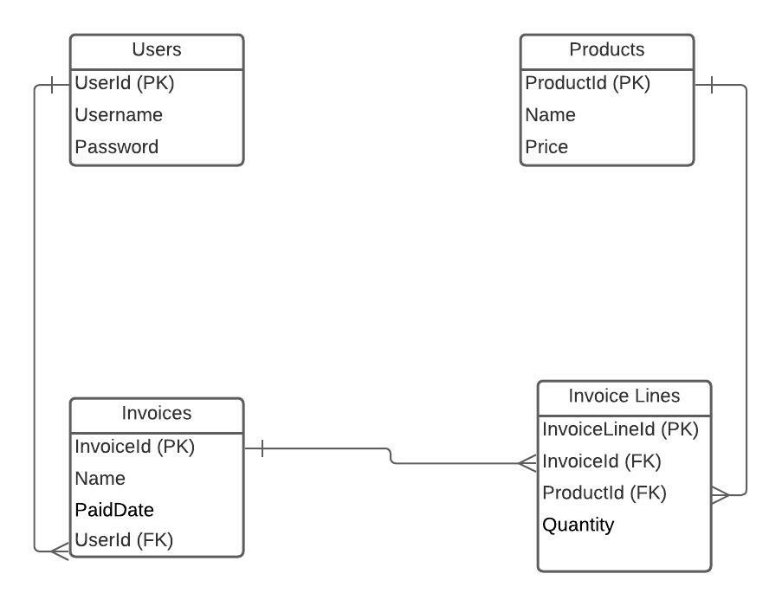

Data of each table is available via OData endpoint.

Users

<https://bever-aca-assignment.azurewebsites.net/users>

Products

<https://bever-aca-assignment.azurewebsites.net/products>

Invoices

<https://bever-aca-assignment.azurewebsites.net/invoices>

Invoice Lines

<https://bever-aca-assignment.azurewebsites.net/invoicelines>

Write a 2 page web application (HTML, JavaScript, CSS) with the following screens.

**Page 1**: User types username and password. If it’s exist in the “Users” table, login the user and navigate to page 2 otherwise no.

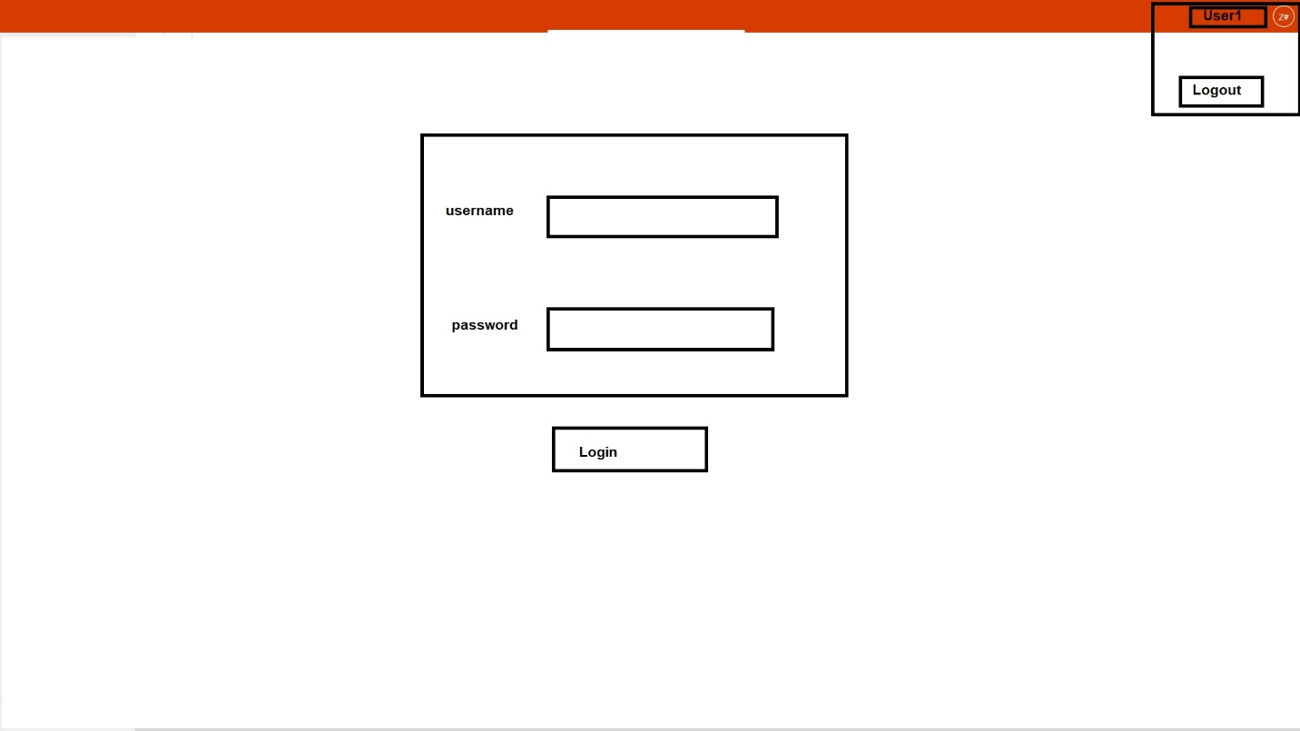

**Page 2**: Show only invoices that related to the logged in user. The “Total Amount” column in “Invoices” table is calculated column. It should be the sum of “total amounts” of related Invoice lines. When user selects an invoice (via radio button) show invoice lines related to that invoice (Table 2).

